In-Text Citations
MLA Format
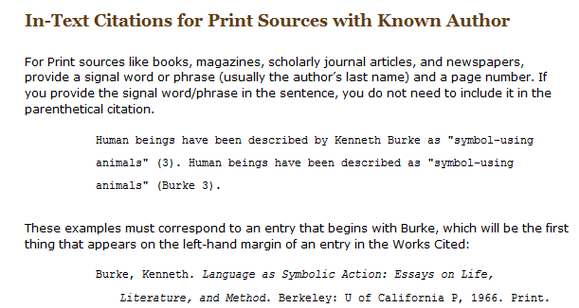

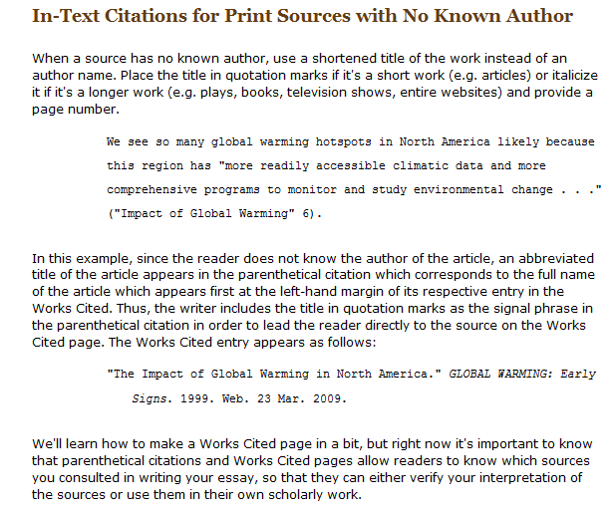
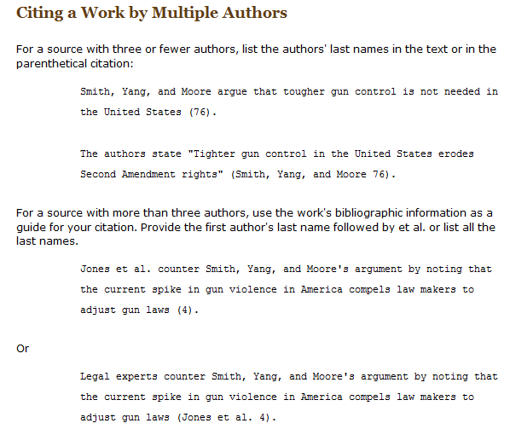

If you are still unsure, please visit the OWL Perdue Online Writing Lab at http://owl.english.purdue.edu/owl/resource/747/02/

